Activity 2.3: Computer performance
- Which computer has the fastest CPU?

- Which computer has the largest amount of permanent storage?

Computer A |  | Computer B
 |  | 
CPU | 2.8 GHz | CPU | 750 MHz
RAM | 8 GB | RAM | 2 GB
Hard drive | 750 GB | Hard drive | 256 GB
Computer C |  | Computer D
 |  | 
CPU | 1.6 GHz | CPU | 3.4 GHz
RAM | 512 MB | RAM | 128 MB
Hard drive | 1 TB | Hard drive | 128 GB

Activity 2.4: Measuring performance (Part 2)
Use the diagrams to help you answer the questions.
You must enter each number without spaces or commas.
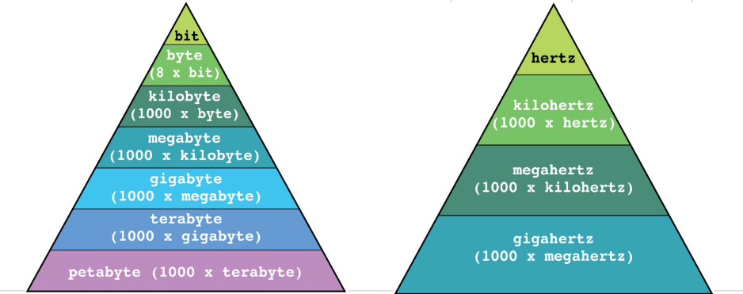
Question |  | Answer
How many bytes in 2 kilobytes? |  |  |  |  |  |  |  | 2000
How many terabytes in 1000 gigabytes? |  |  |  |  |  |  |  | 1
How many megabytes in 5 gigabytes? |  |  |  |  |  |  |  | 5000
How many kilobytes in 2 gigabytes? |  |  |  |  |  |  |  | 2000000
How many bytes in 3 megabytes? |  |  |  |  |  |  |  | 3000000
How many hertz in 4 kilohertz? |  |  |  |  |  |  |  | 4000
How many kilohertz in 6 gigahertz? |  |  |  |  |  |  |  | 6000000

